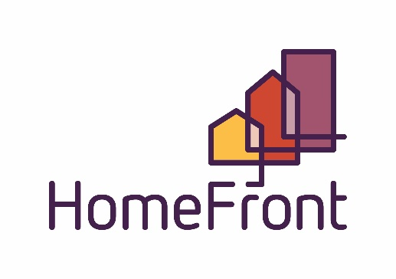
Board of Commissioners Regular Meeting
Location: 2415 1st Ave North, Billings, MT
Large Conference Room
April 17, 2024, 12:00 pm – 1:00 pm

AGENDA

- Call to Order and Determination of Quorum

- Roll Call: Commissioners present on roll call were:
Boos Crawford Hammer Reno Stott Taylor Tusi

- Public Comment on any items not on the agenda (public comment will be limited to 3 minutes for each person)
Sign In Sheet

- Consent Agenda – Separations?
  - Public Hearing
  - Resolution #1225 - Consent Agenda Items
- Meeting Minutes March, 2024
- Financial Summary March 2024
- Contracts
- Public Housing Compliance report
- HCV Housing Compliance report
- Presentation of Current Account Balances
- Claims in the amount of March $ 1,271,807.53 have been reviewed and paid for the previous months. A complete listing of the claims for the previous month is available with the Chief Financial Officer.
- Charge Off’s

- Discussion Agenda
  - CEO Report
    - HUD Reports
    - CRO (Community Reinvestment Organization) approval
RESOLUTION NUMBER 1227

BEFORE THE BOARD OF COMMISSIONERS OF THE
HOUSING AUTHORITY OF BILLINGS
RESOLUTION AUTHORIZING Approval for HAB Development to apply to become a Community Reinvestment Organization

- WHEREAS, the Housing Authority of Billings routinely applies for programs and dollars that align with our mission and vision
- NOW THEREFORE BE IT RESOLVED that the Members of the Housing Authority of Billings Board of Commissioners hereby resolve to apply for HAB Development to apply to become a Community Reinvestment Organization pursuant to HB 819.

- Effective: April 17, 2024

  - CFO Report
  - Policy
    - Public Hearing

RESOLUTION NUMBER 1226

BEFORE THE BOARD OF COMMISSIONERS OF THE
HOUSING AUTHORITY OF BILLINGS
RESOLUTION AUTHORIZING ACCEPTANCE OF THE
Tenant Selection Plan

WHEREAS, the Housing Authority of Billings routinely updates its Multi-Family Project Based Section 8 Tenant Selection Plan in accordance with Housing and Urban Development Department regulations and the Housing Authority of Billings’ own policies,
NOW THEREFORE BE IT RESOLVED that the Members of the Housing Authority of Billings Board of Commissioners hereby resolve to adopt a complete rewrite of the Multi-Family Project Based Section 8
Tenant Selection Plan to comply with HUD’s HOTMA (Housing Opportunity Through Modernization Act).

Effective: May 1, 2024

  - Governance
- Development Committee Report Out
  - Regular Meeting Time for the Development Committee is 2nd Tuesday of each month 2:00 pm – 4:00 pm

- Board Comments and Announcements
- There are now 5 NAHRO Certified Commissioners
  - Hannah Reno
  - Ed Hammer
  - Tom Boos
  - Amanda Taylor
  - Gale Stott

- Adjournment

Next Regular Board Meeting, May 28, 2024

