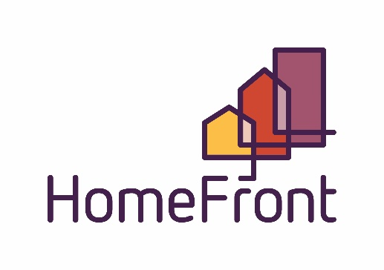
Board of Commissioners Regular Meeting
Location: 2415 1st Ave North, Billings, MT
Large Conference Room
October 26, 2022, 12:00 pm – 1:00 pm

AGENDA

- Call to Order and Determination of Quorum

- Roll Call: Commissioners present on roll call were:
Burton Boos Crawford Hammer Herman Reno Tusi
Tom is excused for this meeting. Hannah will chair the meeting.
Patti will be out of town for Meeting

- Public Comment on any items not on the agenda (public comment will be limited to 3 minutes for each person)
Sign In Sheet

- Consent Agenda – Separations?
  - Public Hearing
  - Resolution #1189 - Consent Agenda Items
- Minutes 9/28/2022
- Public Housing & S8 Quality Control/Compliance report
- Presentation of Current Account Balances, Financials (July)
- Claims in the amount of $ 1,177,725.47 have been reviewed and paid for the previous month. A complete listing of the claims for the previous month is available with the Chief Financial Officer.
- Contract Listing
- Charge Off’s
- HUD Summary Report

- Discussion Agenda
  - CFO Report (written – Patti absent)
- Policy
- Governance
- Development Committee Report Out (Hannah)
- Board Comments and Announcements
There are now 3 NAHRO Certified Commissioners (Carol, Hannah, Ed)
- Adjournment

Next Regular Board Meeting, November 30,2022

