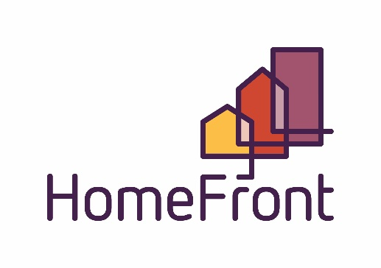
Board of Commissioners Regular Meeting
Location: 2415 1st Ave North, Billings, MT
Large Conference Room
July 27, 2022, 12:00 pm – 1:00 pm

AGENDA

- Call to Order and Determination of Quorum

- Roll Call: Commissioners present on roll call were:
Burton Boos Crawford Hammer Herman Reno Tusi

- Public Comment on any items not on the agenda (public comment will be limited to 3 minutes for each person)
Sign In Sheet

- Consent Agenda – Separations?
  - Public Hearing
  - Resolution #1179 - Consent Agenda Items
- Minutes 6/29/2022
- Public Housing & S8 Quality Control/Compliance report
- Presentation of Current Account Balances, Financials
- Claims in the amount of $1,883,437.25 have been reviewed and paid for the previous month. A complete listing of the claims for the previous month is available with the Chief Financial Officer.
- Contract Listing
- Charge Off’s
- HUD Summary Report

- Discussion Agenda

- CEO/Executive Director Report
  - Public Hearing
    - Disposition Activity – Garage Sale – Resolution # 1180
WHEREAS, the Housing Authority of Billings periodically dispositions items that are no longer of use to the agency, in accordance with Housing and Urban Development Department regulations and the State of Montana Code Annotated,
NOW THEREFORE BE IT RESOLVED that the Members of the Housing Authority of Billings Board of Commissioners hereby resolve to adopt a resolution to allow for a garage sale to dispose of items.
- Public Hearing
Use of Disposition Proceeds – Resolution #1181
WHEREAS, the Housing Authority of Billings has an established Board of Commissioners pursuant to MCA 7-15-4431
NOW THEREFORE BE IT RESOLVED that the Members of the Housing Authority of Billings Board of Commissioners hereby resolve to adopt a resolution to approve the use of disposition proceeds to purchase land for the purpose of developing additional Public Housing.

- CFO Report
- Policy
- Governance
- Committee Structure (no more than 3 commissioners on any committee)
Executive Finance Development
Chair CFO CEO
Vice-Chair CFO
CEO
- Board Comments and Announcements
Please let me know if you want to attend so that we can place on the next agenda for approval of expenditures.
- Commissioner training available

Ethics for Commissioners

Interactive Zoom Meeting

Public e-Learning
- Thursday, August 11, 2022 1:30 PM - 4:00 PMEastern Standard Time

- Adjournment

Next Regular Board Meeting, August 31, 2022

