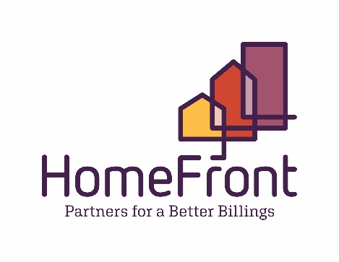
Formerly Housing Authority of Billings
Board of Commissioners Regular Meeting
Location: 2415 1st Ave North, Billings, MT
September 23, 2021 12:00 pm – 1:00 pm
Zoom Meeting ID 929-722-1931 (Invitation will be sent)

AGENDA

- Call to Order and Determination of Quorum
- Public Participation
- Consent Agenda (action required)
- Minutes of June 2021 Board Meeting
- Public Housing and Section 8 Compliance Reports
- Presentation of Current Account Balances, ACH Payments, 7/21 & 8/21 Financials
- Contract Listing
- Charge-Offs Resolution # 1050

- Discussion Agenda

- CEO/Executive Director Report
  - Section 18 Application
  - CEO/Executive Director Authorization Resolution # 1051
  - Update on SFH Disposition
    - Public Relations Specialist
    - Update from Realtors
    - Process Update

- Director of Procurement and Construction Management Update

- CFO Update

- Legal

- Policy

  - Public Housing Admissions & Occupancy Policy to include 3 local preferences already included in Section 8 Administrative Plan.
Resolution # 1052

- Governance
  - New Board Member appointed. Hannah Reno
  - Interim Chair per by-laws
  - Virtual Board training by HDLI
  - Committee for work on by-laws and Standard Operating Procedures for Board
  - Open Meeting Training/Information

- Additions to this Agenda (if 48 hour notice given and noticed appropriately)
- Call for Future Discussion and Information Items
- Board Comments and Announcements

- Adjournment

Next Regular Board Meeting, October 27, 2021

